**September 2021**

**Lake Macquarie City Council Staff Submission**

**Lower Hunter Freight Corridor**

**1.1 Overview of the proposal, high-level impact on Lake Macquarie City**

Lake Macquarie City Council (Council) staff are generally supportive of the recommended Lower Hunter Freight Bypass Corridor proposal (Proposal), and the accompanying Draft Strategic Environmental Assessment 2021 (DSEA) subject to a number of environmental, social and economic considerations being addressed.

Council staff generally support the recommended rail corridor as it will benefit Lake Macquarie City and the wider region by delivering on a number of key strategic objectives:

* increasing passenger train capacity on the main northern railway
* improve freight rail capacity and efficiency to support regional employment growth
* encourage transit-orientated development near suburban train stations

The proposal seeks to connect the Main North Rail Line at Fassifern and the Hunter Valley Rail Network at Hexham, bypassing urban areas within Lake Macquarie and Newcastle Local Government Areas (LGA), while separating passenger and freight rail services through the Greater Newcastle rail network. The need for the proposal is to cater for rising demand on the regional freight rail network, anticipated to grow by 25 per cent over the next 40 years. This will coincide with growth of the Greater Newcastle Metropolitan Area, projected to increase from 575,000 people to 692,000 people by 2036. Much of this growth will occur in the north west of the Lake Macquarie Local Government Area (LGA), which offers one of the last remaining freight and/and passenger rail corridor options that will not significantly impact upon existing urban areas and infrastructure.

To ensure the urgent protection of the corridor, Transport for NSW (TfNSW) seeks to present a finalised corridor for adoption into the *State Environmental Planning Policy (Major Infrastructure Corridors) 2020* by late 2021 to early 2022. Following finalisation, TfNSW will prepare additional implementation and management strategies and comprehensive environmental assessments, subject to the outcomes of a business case to progress the project to a detailed design stage. The project’s eventual construction and operation is not anticipated to occur for a 10 to 20-year period and its timeframe will be influenced by estimated freight growth.

The proposed corridor will be 60 metres wide to provide flexibility for future infrastructure provisions and will eventually operate 24 hours per day, seven days per week. It will traverse land in the north west of the Lake Macquarie LGA, incorporating an area of 86.3ha and have a corridor length of around 14 kilometres. The LHFC will directly impact upon 38 land parcels, which includes 13 private landholders, five government agencies and Lake Macquarie City Council. The largest land parcels the proposal will traverse are those owned by Glencore and the Hunter and Central Coast Development Corporation (HCCDC).

Council has provided a comprehensive response to the proposal in this submission that considers impacts across a range of areas including strategic land use policy, amenity, biodiversity, communities, transport and infrastructure and heritage. We believe it is critical that an integrated land use and transportation outcome is achieved that mitigates and leverages land use constraints and opportunities.

Key points for consideration include the following:

* The corridor’s interface with the North West Lake Macquarie Catalyst Area
* Measures to mitigate potential isolation of Killingworth
* Impact on the Blackrock Motor Park tourism development and Place of public worship at Cameron Park (approved developments)
* Potential provision for future passenger rail or multi-use of the corridor, including a diversity of freight transportation uses
* The need for a comprehensive biodiversity assessment prior to determination of the corridor and concurrent securing of biodiversity offset lands
* Engagement with the Aboriginal community on sites of cultural signifcance
* Potential impacts on heritage sites
* Potential impacts on West Wallsend recreation areas

**1.2 Strategic land use policy**

Council staff are pleased to see progress being made on this much anticipated and important piece of transport infrastructure for the region. The proposal is identified in a wide range of policy and planning documents, and will give effect to a number of strategic objectives in the following:

* Australian Infrastructure Plan 2016
* National Ports Strategy 2011
* National Freight and Supply Chain Strategy 2019
* Future Transport Strategy 2056
* NSW Freight and Ports Plan 2018 – 2023
* Hunter Regional Plan
* Greater Newcastle Metropolitan Plan
* Greater Newcastle Future Transport Plan
* Lake Macquarie Local Strategic Planning Statement

The proposal is generally consistent with strategic outcomes in the policy documents above, however further consideration should be undertaken to align the proposal with transit-orientated development and multi-use service outcomes stated within the Future Transport Strategy 2056, Hunter Regional Plan, Greater Newcastle Metropolitan Plan, Greater Newcastle Future Transport Plan and Lake Macquarie Local Strategic Planning Statement. Refer to *Section 1.3 Land use and transport planning considerations* of this submission for further detail on this matter and recommendations.

**North West Lake Macquarie Catalyst Area**

The proposal is located within the North West Lake Macquarie Catalyst Area (Catalyst Area), Cockle Creek West Precinct (refer Figure 1 below). This Catalyst Area was established under the Greater Newcastle Metropolitan Plan, as a regionally significant gateway to Greater Newcastle, and is estimated to grow by an additional 10,000 people, with the construction of over 4,000 dwellings and creation of 6,000 jobs over the next two decades.

This anticipated growth will place increased demand on passenger and freight rail. A coordinated approach to rail infrastructure investment is therefore required, which the proposal will mostly achieve. The proposal is also listed as a key planning priority within the *North West Lake Macquarie Catalyst Area Priority Plan* and will facilitate the Catalyst Area vision to become the hub for State-significant economic growth in regional NSW by supporting new and diverse jobs to attract people to live and work in Lake Macquarie City and the Lower Hunter. Again, transit-oriented development and multi-use outcomes should be explored to ensure the growing population can be adequately supported.

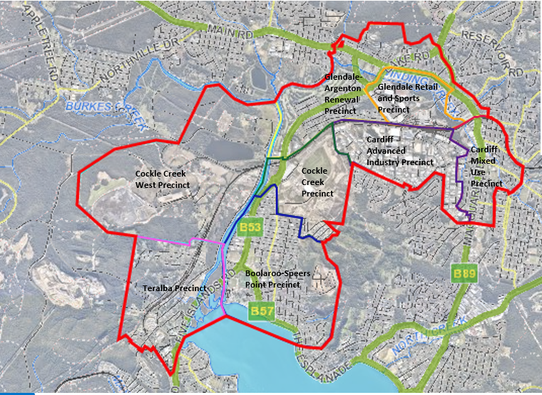

Figure 1: North West Lake Macquarie Catalyst Area boundary

**1.3 Land use and transport planning considerations**

**Land use zoning impacts**

Among other zones, the proposed LHFC will traverse land zoned RU6 Transition under *Lake Macquarie Local Environmental Plan 2014* to the west of the West Wallsend and Holmesville townships (Figure 2). The RU6 Transition Zone is a land use zone that provides opportunity for investigation and potential rezoning to a more suitable land use. Consequently, the proposal may create a barrier for the future development and use of these lands. The proposal would also create amenity impacts for any future development of these lands dependent on the land use outcome.

The *Newcastle-Lake Macquarie Western Growth Corridor Strategy* identified these lands to cater for significant employment and industrial development, with associated freight rail corridor, major road and road interchange to the M1 Motorway. Under the Greater Newcastle Metropolitan Plan these lands were identified as a ‘Housing Release Area’.

Council’s *Local Strategic Planning Statement* identifies these lands for investigation for future development.

It is likely that mitigation measures will need to be considered at the design stage of the proposal to reduce the amenity and other impacts associated with the future development of the RU6 lands.

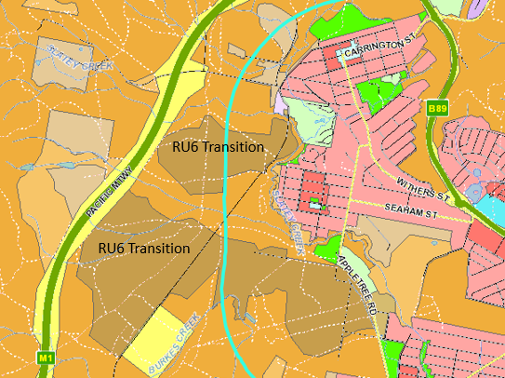

Figure 2: LMLEP 2014 Land use zones near West Wallsend and Holmesville

**Impacts on existing townships and communities**

The proposal will cross The Broadway and may isolate the Killingworth village which could lead to adverse social and amenity impacts to the local community as they will be surrounded by the M1 Motorway and the proposed rail corridor. Therefore, consideration will need to be given at the design stage as to how it is proposed to ensure that Killingworth is not isolated, and is able to remain connected with the wider community particularly during emergency situations like bushfire or a rail accident on the freight bypass.

It is suggested that an alternative to a level crossing be considered, such as a grade separated overpass or underpass, to ensure consistency to section 7.4 of the DSEA and be complaint to safety standards and efficient movement of the transport network.

The LHFC is in close proximity to residential properties in West Wallsend, Holmesville, Killingworth and Barnsley. It is likely that West Wallsend, Holmesville, Killingworth and Barnsley residents will be adversely impacted by noise, vibration, air pollution and general amenity impacts from the proposed corridor. This is illustrated by West Wallsend community members raising ongoing concerns with the existing noise impacts from the M1 Motorway. The bushland that separates the proposed corridor and suburban areas is unlikely to be a suitable mechanism to reduce noise, vibration, air pollution and general amenity impacts. Additional mitigation measures will be required and these measures need to be identified as part of future design stages. The addition of the proposed corridor close to the M1 will likely produce cumulative noise impacts for these communities.

**Recommendations**

1. Undertake further investigation into noise, vibration, pollution and amenity impacts. If these cannot be appropriately mitigated, investigate alternative alignments before the determination of the proposal. It is also requested that the cumulative impact of noise from both the proposed rail and existing M1 Motorway be assessed and that mitigation measures that impact scenic/visual amenity are also assessed.
2. Undertake further engagement with the Killingworth community to understand and mitigate any social or amenity concerns with the proposal’s impact on the village, noting measures that could be undertaken during the design phase of the proposal such as noise mitigation, and alternatives to a level crossing to ensure reliable safe and equitable access for existing communities.
3. Undertake ongoing engagement with directly affected landholders to address impacts and appropriate mitigation measures.

**Multi-use service and transit-orientated development opportunity for the proposal**

As stated in Section 3.1 of the DSEA, the proposal has not actively considered passenger rail or multi-use services within the preliminary design, however it is stated that the proposal will not preclude the delivery of a corridor for use by passenger rail. Nevertheless, it is critical that the 60m wide corridor can support provision of passenger services before finalisation of the proposal to ensure there is no limitation of passenger or multi-use services in future. Consideration of this opportunity for multi-use services would also better align with the long-term passenger and freight rail needs for the Lower Hunter Region as identified in the *Future Transport 2056, Hunter Regional Plan 2036, Greater Newcastle Metropolitan Plan 2036 and Lake Macquarie Local Strategic Planning Statement*. This would also be more consistent with transit-orientated development policy and other current rail projects, such as the Sydney Metro and Sydney Bradfield Airport.

The inclusion of passenger rail connectivity between urban areas such as Holmesville, West Wallsend, Kurri Kurri, Glendale and Maitland has potential to bring transformative urban change and produce significant economic benefits compared to a single-use infrastructure route. Figure 3 outlines such a potential wider regional rail network. This would also support the growing population in the north west of Lake Macquarie, while opening up an additional rail corridor within the Cockle Creek West Precinct in the North West Catalyst Area.

Undertaking this transit-orientated development approach may also offer other benefits for other planned or proposed projects, which were not explored within Section 7.4 of the DSEA, such as:

* Integrating active transport infrastructure within or adjacent to the LHFC to enable a comprehensive active transport network to the north west of Lake Macquarie which connects from multiple existing routes.
* Ensuring that the design of the LHFC accommodates proposed regional cycleway projects such as the ‘Shiraz to Shore’ and the Richmond Vale Rail Trail.
* Expanding the scope of the NSW Government’s faster rail project to include this proposal which may realise wider rail network improvements and corridor options.
* Exploring corridor alignment opportunities with the Federal Government’s proposed Very Fast Train (VFT).

There may be opportunity to better incorporate the VFT corridor and VFT West Wallsend station with the proposal. Figure 4 identifies possible opportunity to align the VFT corridor, existing electrical transmission easement and the proposal to reduce biodiversity and amenity impacts. In addition, the proposal may conflict with the proposed VFT station limiting access options from West Wallsend and Holmesville.

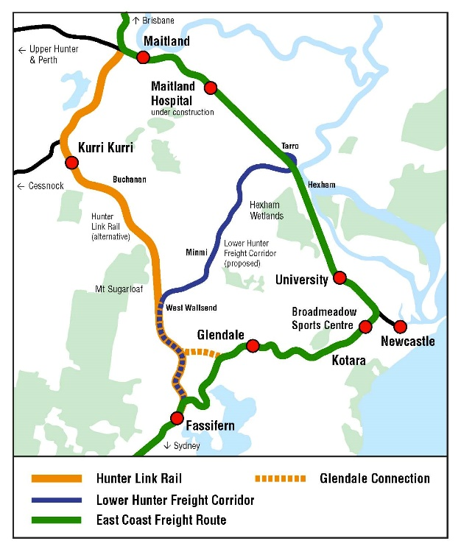

Figure 3: Concept of wider Greater Newcastle network (Hunter Environment Lobby Inc)

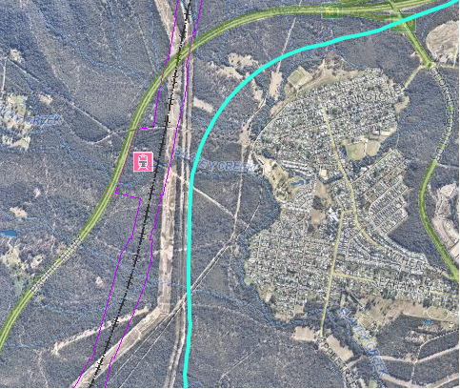

Figure 4: Interface of the LHFC, Very Fast Train corridor and station (in purple), and existing electrical transmission easement

Therefore, it is recommended that transit-oriented development and multi-use opportunities are considered at this stage of the project, to ensure that the corridor can adequately deliver and service both freight and passenger services in the future. This consideration needs to include passenger train station locations.

**Impact on the Cockle Creek West Precinct of the North West Lake Macquarie Catalyst Area**

The proposal will traverse land within the Cockle Creek West Precinct of the North West Lake Macquarie Catalyst Area (Figure 5). This precinct may undergo significant change from the adaptive reuse of ex-mining land in a medium to long-term future. This adaptive reuse outcome may also provide improved road connections east to west connecting Cockle Creek to the M1 Motorway, while utilising existing private haulage road and rail infrastructure.

In addition, if the proposal were to consider a transit-orientated development outcome, such as passenger services, station(s) or co-locating supporting industries, this may provide a catalyst to realise the full potential of brownfield development of these lands.

If the Precinct underwent adaptive reuse, local planning policies would be prepared to identify appropriate land use and transport infrastructure, which would likely commence before the final design of the proposal. Therefore, at this time, consideration should be given to mitigating any conflicts with road connections, land use layouts and integration of any transit-orientated development outcomes.

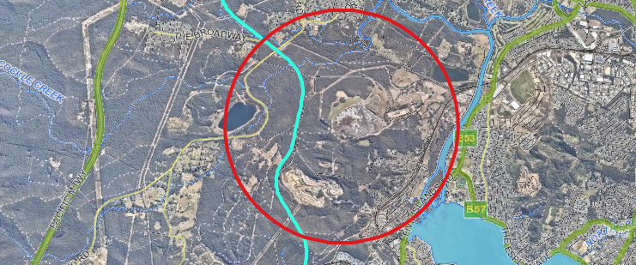

Figure 5: Cockle Creek West area

**Recommendations**

1. Undertake further engagement with the Hunter and Central Coast Development Corporation to understand their intent for the future development of the RU6 zoned land and ensuring the proposal can accommodate road and infrastructure connections to realise the development objectives of the land.
2. Investigate transit-orientated development and multi-use opportunities and alternatives before final determination of the corridor. This includes optimising and integrating corridor alignments with other planned or proposed rail and active transport projects.
3. Ensure the design of the corridor accommodates proposed regional cycleway projects such as the ‘Shiraz to Shore’ and the Richmond Vale Rail Trail.
4. Undertake further engagement with Council, Glencore and the Department of Planning, Industry and Environment to understand the intent for the Cockle Creek West Precinct lands and ensure that future adaptive reuse and transport network opportunities can be realised.

**1.4 Economic considerations and development applications**

**Economic considerations**

The proposal will have a beneficial economic outcome for Greater Newcastle, as it will enable the separation of freight and passenger services through the most densely populated areas of the region and will have significant net-benefits, including:

* Reduction in traffic congestion at multiple railway crossings;
* An improved suburban public transport system;
* Increased amenity and liveability for residents on the existing rail network;
* Increased opportunities and desirability of transit-orientated developments along the existing rail network through urban areas;
* Potential reduction in emissions from reduction in the need for road-based freight movements;
* Improved access to regional markets to the north and west of NSW.

Opportunities for co-location of supporting industries that would benefit from direct access to the rail line should be investigated and planned. This could include maintenance yards, heavy industrial precincts, and multi-nodal logistics and freight distribution centres.

In addition, when preparing the future business case for this project, the economic basis should be assessed against the proposal being utilised for a diversity of freight transportation uses, not just coal transportation. This position will reflect the current and future transition away from coal and the changing operational position of the Port of Newcastle.

**Proposed and future development**

Securing the corridor and providing relevant planning provisions will provide a clear assessment framework for any future development applications, where impacts from and to the corridor can be considered.

**Approved and existing development**

There are direct and indirect impacts from the proposal to applications already approved and/or existing. Two major approved development applications that will be affected are outlined below.

* BlackRock Motor Park at Wakefield (DA/1556/2017 - 282 Rhondda Road, WAKEFIELD (Lot 101 DP1073163 & Lot 1 DP963356)

The proposal is likely to traverse both lots of the development and will cause an adverse impact on the location and amenity of approved structures of the development, in particular accommodation units. The proposal may result in the approved development becoming unfeasible due to the amenity and restriction on accommodation. Overall, this would be an adverse outcome as the capital investment value of the development is $85 million, with the potential generation of 200 jobs and the adaptive reuse of a disused mining site. It is recommended that affected landholders are engaged to ensure minimal impact to approved development through appropriate realignment and design options or mitigation measures.

* Place of public worship in Cameron Park industrial area (DA/1393/2020 – 100 Stenhouse Drive, Cameron Park Lot 11 DP 1256166)

The proposal will traverse the northern property boundary of the approved development and will impact both access and car parking arrangements prescribed as a condition of consent. The proposal will also have an adverse impact on the amenity of the approved development. It is recommended that affected landholders are engage to ensure minimal impact to approved development through appropriate realignment options or mitigation measures.

**Recommendations**

1. Explore opportunities for co-location of supporting industries that would benefit from direct access to the line, such as maintenance yards, heavy industrial precincts, and multi-nodal logistics and freight distribution centres.
2. Ensure any future business case for this project is assessed against the proposal being utilised for a diversity of freight transportation uses and not being primarily used for coal transportation.
3. Engage with landholders with active development consents to inform the finalised corridor to mitigate any adverse impacts. In particular, the two major developments – BlackRock Motor Park at Wakefield and Place of Worship at Cameron Park industrial estate.

**1.5 Biodiversity**

In the Lake Macquarie LGA, 107.69 ha of total vegetation is affected by the 60-metre-wide corridor (excluding the vegetation in the tunnel section). This comprises 86.82 ha bushland, 15.8 ha partially cleared vegetation and 5.06 ha partially cleared easement vegetation. The total area of Threatened Ecological Community’s (within the above total) is 18.35 ha Lower Hunter Spotted Gum Ironbark Forest, and 24.48 ha River Flat Eucalypt Forest on Coastal Floodplains.

Construction of the proposal would represent a significant impact on both state and nationally listed threatened species and ecological communities within the Lake Macquarie LGA. The proposal also crosses a large wetland mapped in State Environmental Planning Policy Coastal Management 2018.

**Biodiversity impacts**

Overall there are three types of biodiversity impacts from the proposal.

1. Direct impacts associated with clearing and loss of native vegetation, especially high-value biodiversity such as threatened species and their habitats. Important species potentially impacted include the Koalas, Squirrel Glider, Tetratheca juncea, Grevillea parviflora subsp. parviflora, Callistemon linearifolius, and large forest owl species, and other avifauna.
2. Fragmentation of existing habitat, and impacts on habitat connectivity. The main consequences of fragmentation are: to reduce vegetation patch size and the ability to sustain species populations; to increase the perimeter and vulnerability of natural areas to disturbance; and to limit the spread and movement of species, with consequent effects on population and genetic viability.
3. Indirect impacts such as changes to hydrology and water-dependent ecosystems, noise and light exposure, spread of weeds and feral animals.

While biodiversity impacts are considered in the DSEA, this represents an initial desktop review rather than a comprehensive biodiversity assessment. Section 5.1.3 of the DSEA (p.30) states that “any potential impact on fauna and flora would need to be investigated as part of future design and environmental approval process” and also notes the importance of biodiversity connectivity and green corridors in the area. However, the best opportunity to avoid biodiversity impacts occur during the selection of the route. Once the 60m wide alignment is determined, the opportunity to avoid and mitigate biodiversity impacts during the design and environmental approval process are limited.

The DSEA is not an adequate basis for environmental assessment, as the proposal will permanently affect future land use and the spatial pattern of remnant vegetation in the north west of Lake Macquarie LGA. Limitations of the biodiversity assessment in the DSEA are as follows:

* Information on biodiversity corridors and connectivity dates from 2001 and is out of date and regional in scale. It does not adequately consider long-term strategic conservation requirements or local species characteristics and requirements.
* Figure 5.4 Ecological Features is based on regional scale information and not more accurate local data. It should be checked for accuracy and include identification of existing biodiversity offset areas shown on the Lake Macquarie City Council database. It is also not clear what the “Other Parks’ category on the map refers to.
* The biodiversity assessment in Section 7.9 of the DSEA has not included sufficient information to identify significant biodiversity values, or how impacts on these can be avoided. For example, impacts of the corridor through a significant coastal wetland.
* Additional field surveys need to be undertaken for important threatened species prior to the finalisation of the corridor. In particular, this relates to koalas, large forest owls, ground orchids, and any other species that could be subject to potential serious and irreversible impacts from the project. Council has a range of flora and fauna survey guidelines that could assist.
* An assessment of the fragmentation of habitat and cumulative biodiversity impact as a result of the proposal should be undertaken, together with opportunities to reserve suitable biodiversity offsets before determination of the corridor. The current proposal severs a number of critical native vegetation corridors and in places adds to the width of other hostile barriers within the north west of the LGA. The impact of this on the viability of threatened species populations in the north west of the LGA needs to be quantified and assessed.
* Opportunities to mitigate impacts from the proposal need to be considered at the strategic environmental assessment stage, and throughout the project design process. For example, fauna and flora bridges, overpasses and underpasses need to be considered at the initial corridor selection stage as does the identification and protection of biodiversity offset areas.
* The proposed alignment will increase the effect of multiple linear barriers (i.e. motorway, railway, transmission line easements, and service roads) that seriously undermine habitat connectivity by creating one complex barrier of up to 1km wide that will not allow species movement. This cumulative impact is not addressed in the Biodiversity Assessment Method normally used for assessing biodiversity impacts and offset requirements.
* Other options for nearby infrastructure should be included within the project options, such as realignment of powerlines and easements, and potential for undergrounding these powerlines to reduce future fire hazards and long-term easement impacts.
* Biodiversity impacts should be considered in the cumulative assessment in Section 7.16.1 of the DSEA. Section 7.16.1 also provides limited information for all cumulative impacts as the only cumulative impacts identified are transport-related. There is a wide range of other cumulative impacts as a result of the project such as biodiversity impacts, hydrological impacts and also urban development, social and land use consequences.
* Options for avoiding biodiversity impacts have not been documented including the use of tunnels or bridges to avoid surface impacts.

**Biodiversity offsets**

To compensate for the anticipated loss of biodiversity in Lake Macquarie LGA, a large offset area of around 400 – 1000 ha is likely to be required. The biodiversity offset should be identified and ideally secured at the same time as the corridor is determined. The offset should ideally also be located within the Lake Macquarie LGA. If offsets are not identified and secured at this stage, it may be difficult or impossible to source suitable offsets in the future when required, and the future cost is likely to be significantly more expensive. It is recommended to undertake further ecological assessment to quantify and secure offsets in the short term.

Staff support Section 7.9 of the DSEA to identify biodiversity offsets on strategically located NSW Government-owned land for potential offset areas, and that these could build on and adjoin the existing National Parks and Wildlife Service reserve estate. It is important to note, however, that these areas may be used to offset other development projects before the LHFC reaches the design and/or construction stage.

Biodiversity impacts from the proposal are significant and represent a potential financial risk to this project. This can be avoided through undertaking more detailed biodiversity survey and assessment and locality-specific strategic conservation planning. Staff from Lake Macquarie City Council are willing and available to assist in this regard.

**Recommendations**

1. Undertake a comprehensive biodiversity assessment and survey prior to finalisation of the corridor to provide certainty of biodiversity values affected, cumulative impacts, and the expected biodiversity offset requirement to incorporate biodiversity mitigation measures into the project’s design.
2. Identify and secure biodiversity offset lands concurrently with the reservation of the corridor to minimise project financial risk in the future. In addition, biodiversity offsets within the Lake Macquarie LGA are preferred.

**1.6 Heritage and visual impact**

The proposal will have both direct and indirect impacts on Aboriginal heritage and non-Aboriginal heritage, including visual and scenic qualities that contribute to heritage character and landscape.

**Aboriginal Heritage**

The DSEA states: “A strategic review of Aboriginal heritage found that the impact of the protection of the Lower Hunter Freight Corridor on Aboriginal heritage would be negligible” (p.83). However, the analysis also found that there “could be potential impacts from the provision of any future infrastructure within the recommended corridor, depending on detailed studies and ground truthing”. (p.83). Additionally, the study also acknowledged that “the recommended corridor would pass through areas of cultural heritage, specifically the Cockle Creek catchment and areas between Mount Sugarloaf and Hexham Swamp” and “The significance of Aboriginal heritage and potential for discovery of sites and artefacts will, however, require on-going investigation”. (p.82). The Lake Macquarie Aboriginal Heritage Management Strategy (2011) provides a valuable resource to assist with this matter.

Mount Sugarloaf is a place of deep spiritual significance to Aboriginal people and this significance is confirmed by the current Aboriginal community and by ethnographic documentation made by the Reverend Threlkeld in the 1820-30s. The impact of the proposal on this place as well as the Aboriginal sites which surround it need to be fully assessed before determination of the proposal.

It is recommended, that prior to the proposal being determined, further indigenous heritage assessment is undertaken in consultation with Aboriginal stakeholders. This further assessment will provide the opportunity to avoid impacts on significant Aboriginal heritage sites and cultural values, and future project delivery risks.

**Recommendations**

The following should be undertaken before determination of the proposal to ensure that the significance of any Aboriginal sites or places is sufficiently understood and mitigation measures can be considered:

1. Continue engagement with relevant members of the Aboriginal community to protect cultural values and unrecorded sites associated with the recommended corridor, and carry out engagement in accordance with the relevant Heritage NSW guidelines
2. Undertake archaeological surveys of the recommended corridor including ground truthing of previously identified sites, in consultation with the Aboriginal community.
3. Identify opportunities to avoid direct or unacceptable impacts to heritage values and items and develop appropriate management strategies in relation to Aboriginal heritage. This could include opportunities for archaeological salvage work, archival recording, interpretation and cultural inductions.
4. Consider subsurface archaeological testing within the recommended corridor utilising best practice guidelines.

Following the finalisation of the proposal and prior to commencing construction, a construction heritage management plan should be developed in consultation with relevant members of the Aboriginal community. This should include protocols for archaeological monitoring and unexpected finds.

**Non-Aboriginal Heritage**

The DSEA, acknowledges that “the recommended corridor passes through or is in close proximity to a number of non-Aboriginal heritage items that relate to the mining and transport history of the Hunter Valley” including a number of local heritage items” (p.83). The DSEA states that “potential indirect impacts on nearby heritage items would depend on the design of the future trail infrastructure. As such, this would be considered during the next phase of design development”. (p. 83). If the proposal is finalised prior to further assessment, the opportunity to avoid impacts on significant non-Aboriginal heritage sites and cultural values, informed by further engagement with the local community and relevant heritage experts, will be limited.

**West Wallsend HCA**

The West Wallsend Heritage Conservation Area (HCA) is embedded in a cultural landscape representative of the development of coal mining in the area. This is made from a variety of structures including former coal mine sites, mine dams, railway lines with associated cuttings, embankments and culverts, and the townships which developed around them to house the mine workers, as well as their bushland landscape setting. The landscape setting is an important part of the visual curtilage or setting of the West Wallsend and Holmesville historic townships, as well as being part of the wider cultural landscape.

Council has recently updated the statement of significance and prepare a views analysis. The result of these assessments is the recommended expansion of the boundary of the West Wallsend HCA to:

* Protect significant views and vistas that contribute to the setting, character and significance of the area, and
* Provide a visual and spatial buffer between the HCA and any medium to high density residential or commercial development proposed in the future.

These same considerations should be considered in determining the finalised proposal.

Council will share this Working Report with TfNSW and the HCCDC to discuss impacts and opportunities in more detail.

**Visual impact on Heritage Items**

The proposal will impact on two locally listed heritage items. These include:

* West Wallsend No. 1 (Former Colliery Site), 125 George Booth Drive, West Wallsend (Lot 106 DP 1000408)

The West Wallsend No.1 Colliery was the original mine that enabled the creation and development of the West Wallsend township. It is socially and culturally significant to the township, while offering the natural landscape setting that is characteristic of West Wallsend and Holmesville. The proposal traverses through the locally listed site and will likely produce visual, amenity and other heritage related impacts. Additionally, part of the site is planned to be developed into a neighbourhood park – refer to *Section 1.8 Council owned land and recreation / community facilities* of this submission for further detail on impacts and suggested mitigation measures.

* West Wallsend Cemetery, 6 Cemetery Road, West Wallsend (Lot 981 DP 589701)

The proposal cuts across the access road to the West Wallsend Cemetery, physically separating and isolating it from the township. This will produce connectivity, visual, amenity and other heritage related impacts. Consideration of connecting the Cemetery with the township will need to be undertaken at the later stage of this project with options explored for either an underpass, overpass or a separated signalled rail-crossing.

**Historic Mines**

Figure 5.5 of the DSEA, “Historical mine workings and areas of subsidence”, has not identified a number of historic mine sites to the west of Killingworth, Holmesville and West Wallsend. Some of these sites have not been locally listed to date and require detailed mapping, heritage significance assessment and recording. Due to their age and potential for shallow workings, they may also require more detailed assessment in relation to both subsidence and contamination.

**Recommendations**

The following should be undertaken before determination of the final corridor to ensure that the significance of heritage items is sufficiently understood and mitigation measures can be considered:

1. Undertake archaeological surveys of the recommended corridor including ground truthing of previously identified sites, in consultation with the local community and relevant heritage experts.
2. Undertake a heritage impact assessment and views impact analysis to assess the impact of the recommended route on identified heritage items in the vicinity. Any heritage impact assessment needs to include an assessment of the impact of the proposed rail line on the cultural landscape as a whole.
3. Identify opportunities to avoid direct or unacceptable impacts to heritage values and items and develop appropriate management strategies in relation to non-Aboriginal heritage. This could include opportunities for archaeological salvage work, archival recording, interpretation and archaeological inductions.
4. Consider subsurface archaeological testing within the recommended corridor utilising best practice guidelines, and the excavation permit requirements under the *Heritage Act* 1974.
5. Consider the mitigation of any potential visual impacts on heritage items by the retention and protection of surrounding bushland as both a green buffer and biodiversity offset land.
6. Undertake geotechnical assessments (at the design stage) to understand the mine subsidence risk and impact to historic mines.
7. Following the adoption of the proposal and prior to commencing construction, a construction heritage management plan should be developed in consultation with a professional historical archaeologist. This should include protocols for archaeological monitoring and managing unexpected finds, as required under the relic provisions of the *Heritage Act* 1977.

**1.7 Council owned land and recreation / community facilities**

The proposal has direct and indirect impacts on land owned and managed by Lake Macquarie City Council.

Council-owned land is classified as either:

* Community land – Council-owned land which is kept for use by the general public and would ordinarily comprise land such as a public park.
* Operational land – Council-owned land which is a temporary asset, permanent asset or an investment. This land facilitates the carrying out of functions by a council, which may not be open to the general public, such as a works depot or a council garage.

**Operational landholdings**

The proposal does not directly impact on any Council’s Operational Land holdings.

As identified within the DSEA, the proposal has an indirect impact on West Wallsend Cemetery, 6 Cemetery Road, West Wallsend (Lot 981 DP 589701) which is Operational Land and part Community Land. Refer to *Section 1.6 Heritage and Visual Impact* of this submission for detail on impacts and mitigation recommendations.

**Community facilities**

The proposal does not directly affect any community facilities (i.e., community centres/halls etc).

**Community landholdings**

As identified within the DSEA, the proposal has direct impact on the following Community Lands and recreational areas.

* Johnson Park West Wallsend (Lot 1 DP 421411) and proposed West Wallsend neighbourhood park (Lot 106 DP 1000408)

Council has adopted plans to expand and embellish Johnson Park (Facility reference: OS-009) and a provide a neighbourhood park to the east (Facility reference: OS-038). The proposed recreation developments are to occur with consultation and agreement with the current land owners, Hunter and Central Coast Development Corporation.

The proposal has the potential to impact the amenity, visual aesthetic and heritage significance of the proposed park. The proposed neighbourhood park’s location was chosen due to the bushland views and vistas, and its heritage significance to the West Wallsend township, as the site was the location of the original West Wallsend (No 1) Colliery, which influenced the township’s creation and development.

A map showing the proposed expansion of Johnson Park and neighbourhood park are provided below.

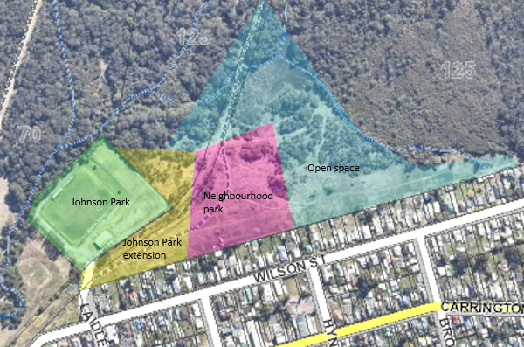

Figure 6: West Wallsend Park Proposal

* Mountain bike tracks (Lot 1 DP529869, Lot 1 DP1030193, Lot 651 DP571041, Lot 2 DP529869, Pt Lot 34 DP 1147597, Lot 1 DP 1123177)

The proposal traverses HCCDC’s landholdings at West Wallsend and Holmesville, which have an extensive network of mountain bike tracks. The mountain bike tracks are managed by the Holmesville Mountain Bike Riders and are signposted, with the main access point at Appletree Road, at Kevin Evans Oval.

The principal areas of conflict in regards the current ‘formalised’ mountain bike trails and the proposed route relate to the following parcels Lot 1 DP529869, Lot 1 DP1030193 and Lot 651 DP571041. These areas may be isolated and disconnected by the proposed rail corridor.

Whilst acknowledging that these tracks have been built on HCCDC’s landholdings, they do provide an important community asset for mountain biking, attracting local and regional visitors. The land is relatively flat, focuses on low-level cross-country riding, suitable for families, and thus complements other, more challenging tracks in the region.

* Public Reserve, 12C Billbrooke Close, Cameron Park (Lot 336 DP 1089554)

The proposal traverses community land categorised as a natural area. As this area is used for conservation purposes, there are no plans for any development on this area, rather maintaining its biodiversity value into the future. Compensation for the use or acquisition of this land will be required by Council.

As identified within the DSEA, the proposal also indirectly impacts:

* Fassifern Oval, 51 Miller Road, Fassifern (Lot 259 DP 1139078)
* Newtec Pistol Club, 158 Rhondda Road. Teralba (Lot 1 DP 224037)
* Taylor Park, 1A Johnson Avenue, Barnsley (Lot 1 DP 224037)
* Kevin Evans Oval, 60A Appletree Road, Holmesville (Lot 650 DP 571041)

No specific investigations would be required for these sites.

**Recommendations**

1. Undertake further investigations into mitigating potential visual and amenity impacts on Johnson Park and the proposed West Wallsend neighbourhood park. This may include provision of landscape buffers, via retention of surrounding bushlands or biodiversity offsets or providing appropriate alternative lands to accommodate the park.
2. Undertake further investigation into noise and vibration impacts on Johnston Park and the proposed West Wallsend neighbourhood park at the next stage of the project’s development.
3. Explore opportunities to co-locate, design and mitigate impacts for the proposed neighbourhood park at West Wallsend. Further engagement with Council, TfNSW and the HCCDC is strongly recommended.
4. Explore opportunities for the proposal and existing mountain bike uses to co-locate or providing appropriate alternative lands to accommodate the mountain bike park. Further engagement with Council, TfNSW, HCCDC and the Holmesville Mountain Bike Riders is strongly recommended.

**1.8 Impact on local road infrastructure**

The proposal will cross the Hunter Expressway, George Booth Drive, The Broadway, Wakefield Drive, Cemetery Road, O’Donnelltown Road, Killingworth Road and Rhondda Road. Subject to appropriate separated crossings there will likely be minimal impact on the operation of the local road network, which is maintained by Council.

The use of grade separated crossings of all local roads, as identified in section 7.4 of the DSEA, is considered critical to achieve safety and efficiency objectives. Each of these graded separated crossings, particularly across major roads, provides opportunity for shared infrastructure and an evaluation of impacts should be considered during the development of the project.

The proposed tunnel between Fassifern and Rhonda Road quarry will achieve a beneficial outcome as it would allow for future connections and land use opportunities through this area including rerouting the Great Northern Walk between Wakefield to Teralba from its current route on Wakefield Road and Rhondda Road.

**Recommendation**

1. Undertake further investigations at the design stage of the project to ensure shared crossing points reduce conflicts, safety risks, impacts on traffic flow, and the connectivity of road and active infrastructure networks.

**Contact**

Council appreciates the opportunity to contribute to this consultation process and welcomes further engagement. For follow-up discussions or inquiries, please contact:

**Wes Hain**

Manager, Integrated Planning

P: 02 4921 0271

E: whain@lakemac.nsw.gov.au

**Collated list of recommendations**

**Impacts on existing townships and communities**

1. Undertake further investigation into noise, vibration, pollution and amenity impacts. If these cannot be appropriately mitigated, investigate alternative alignments before the determination of the proposal. It is also requested that the cumulative impact of noise from both the proposed rail and existing M1 Motorway be assessed and that mitigation measures that impact scenic/visual amenity are also assessed.
2. Undertake further engagement with the Killingworth community to understand and mitigate any social or amenity concerns with the proposal’s impact on the village, noting measures that could be undertaken during the design phase of the proposal such as noise mitigation, and alternatives to a level crossing to ensure reliable safe and equitable access for existing communities.
3. Undertake ongoing engagement with directly affected landholders to address impacts and appropriate mitigation measures.

**Impact on the Cockle Creek West Precinct of the North West Lake Macquarie Catalyst Area**

1. Undertake further engagement with the Hunter and Central Coast Development Corporation to understand their intent for the future development of the RU6 zoned land and ensuring the proposal can accommodate road and infrastructure connections to realise the development objectives of the land.
2. Investigate transit-oriented development and multi-use opportunities and alternatives before final determination of the corridor. This includes optimising and integrating corridor alignments with other planned or proposed rail and active transport projects.
3. Ensure the design of the corridor accommodates proposed regional cycleway projects such as the ‘Shiraz to Shore’ and the Richmond Vale Rail Trail.
4. Undertake further engagement with Council, Glencore and the Department of Planning, Industry and Environment to understand the intent for the Cockle Creek West Precinct lands and ensure that future adaptive reuse and transport network opportunities can be realised.

**Economic considerations and development applications**

1. Explore opportunities for co-location of supporting industries that would benefit from direct access to the line, such as maintenance yards, heavy industrial precincts, and multi-nodal logistics and freight distribution centres.
2. Ensure any future business case for this project is assessed against the proposal being utilised for a diversity of freight transportation uses and not being primarily used for coal transportation.
3. Engage with landholders of active development consents to inform the finalised corridor to mitigate any adverse impacts. In particular, the two major developments – BlackRock Motor Park at Wakefield and Place of Worship at Cameron Park industrial estate.

**Biodiversity**

1. Undertake a comprehensive biodiversity assessment and survey prior to finalisation of the corridor to provide certainty of biodiversity values affected, cumulative impacts, and the expected biodiversity offset requirement to incorporate biodiversity mitigation measures into the project’s design.
2. Identify and secure biodiversity offset lands concurrently with the reservation of the corridor to minimise project financial risk in the future. In addition, biodiversity offsets within the Lake Macquarie LGA are preferred.

**Aboriginal Heritage**

1. Continue engagement with relevant members of the Aboriginal community to protect cultural values and unrecorded sites associated with the recommended corridor, and carry out engagement in accordance with the relevant Heritage NSW guidelines
2. Undertake archaeological surveys of the recommended corridor including ground truthing of previously identified sites, in consultation with the Aboriginal community.
3. Identify opportunities to avoid direct or unacceptable impacts to heritage values and items and develop appropriate management strategies in relation to Aboriginal heritage. This could include opportunities for archaeological salvage work, archival recording, interpretation and cultural inductions.
4. Consider subsurface archaeological testing within the recommended corridor utilising best practice guidelines.

**Non-Aboriginal Heritage**

1. Undertake archaeological surveys of the recommended corridor including ground truthing of previously identified sites, in consultation with the local community and relevant heritage experts.
2. Undertake a heritage impact assessment and views impact analysis to assess the impact of the recommended route on identified heritage items in the vicinity. Any heritage impact assessment needs to include an assessment of the impact of the proposed rail line on the cultural landscape as a whole.
3. Identify opportunities to avoid direct or unacceptable impacts to heritage values and items and develop appropriate management strategies in relation to non-Aboriginal heritage. This could include opportunities for archaeological salvage work, archival recording, interpretation and archaeological inductions.
4. Consider subsurface archaeological testing within the recommended corridor utilising best practice guidelines, and the excavation permit requirements under the *Heritage Act* 1974.
5. Consider the mitigation of any potential visual impacts on heritage items by the retention and protection of surrounding bushland as both a green buffer and biodiversity offset land.
6. Undertake geotechnical assessments (at the design stage) to understand the mine subsidence risk and impact to historic mines.

**Council owned land and community/recreation facilities**

1. Undertake further investigations into mitigating potential visual and amenity impacts on Johnson Park and the proposed West Wallsend neighbourhood park. This may include provision of landscape buffers, via retention of surrounding bushlands or biodiversity offsets.
2. Undertake further investigation into noise and vibration impacts on Johnston Park and the proposed West Wallsend neighbourhood park at the next stage of the project’s development.
3. Explore opportunities to co-locate, design and mitigate impacts for the proposed neighbourhood park at West Wallsend. Further engagement with Council, TfNSW and the HCCDC is strongly recommended.
4. Explore opportunities for the proposal and existing mountain bike uses to co-locate. Further engagement with Council, TfNSW, HCCDC and the Holmesville Mountain Bike Riders is strongly recommended.

**Impact on local road infrastructure**

1. Undertake further investigations at the design stage of the project to ensure shared crossing points reduce conflicts, safety risks, impacts on traffic flow, and the connectivity of road and active infrastructure networks.